SET UTF-8 cho ứng dụng Spring

* Ở config init:

@Override  
protected Filter[] getServletFilters() {  
 // создание фильтра кодировки, который позволит работать с русскими символами  
 CharacterEncodingFilter characterEncodingFilter = new CharacterEncodingFilter();  
 characterEncodingFilter.setEncoding("UTF-8");  
 characterEncodingFilter.setForceEncoding(true);  
  
 // создание фильтра, который добавляет поддержку HTTP методов(например,таких как PUT)  
 HiddenHttpMethodFilter httpMethodFilter = new HiddenHttpMethodFilter();  
 return new Filter[]{characterEncodingFilter, httpMethodFilter};  
}

* Ở config app

@Bean  
public SpringResourceTemplateResolver templateResolver() {  
 SpringResourceTemplateResolver templateResolver = new SpringResourceTemplateResolver();  
 templateResolver.setApplicationContext(applicationContext);  
 templateResolver.setPrefix("/WEB-INF/views/");  
 templateResolver.setSuffix(".html");  
 templateResolver.setCharacterEncoding("UTF-8");  
 templateResolver.setTemplateMode(TemplateMode.*HTML*);  
 return templateResolver;  
}

@Bean  
public ThymeleafViewResolver viewResolver() {  
 ThymeleafViewResolver viewResolver = new ThymeleafViewResolver();  
 viewResolver.setTemplateEngine(templateEngine());  
 viewResolver.setCharacterEncoding("UTF-8");  
 viewResolver.setContentType("text/html; charset=utf-8");  
  
 return viewResolver;  
}

@Bean  
public DataSource dataSource() {  
 DriverManagerDataSource dataSource = new DriverManagerDataSource();  
 dataSource.setDriverClassName("com.mysql.cj.jdbc.Driver");  
 dataSource.setUrl("jdbc:mysql://localhost:3306/news-app-db?useUnicode=true&characterEncoding=UTF-8" +  
 "&useJDBCCompliantTimezoneShift=true&useLegacyDatetimeCode=false&serverTimezone=UTC");  
 dataSource.setUsername("root");  
 dataSource.setPassword("");  
 return dataSource;  
}

Properties additionalProperties() {  
 Properties properties = new Properties();  
 properties.setProperty("hibernate.hbm2ddl.auto", "update");  
 properties.setProperty("hibernate.connection.useUnicode","true");  
 properties.setProperty("hibernate.connection.characterEncoding","UTF-8");  
 properties.setProperty("hibernate.connection.charSet","UTF-8");  
 properties.setProperty("hibernate.dialect", "org.hibernate.dialect.MySQL5Dialect");  
 return properties;  
}

@Bean  
public MessageSource messageSource() {  
 ResourceBundleMessageSource messageSource = new ResourceBundleMessageSource();  
 messageSource.setBasename("message");  
 messageSource.setDefaultEncoding("UTF-8");  
 return messageSource;  
}

* Set ở setting cho file i18n

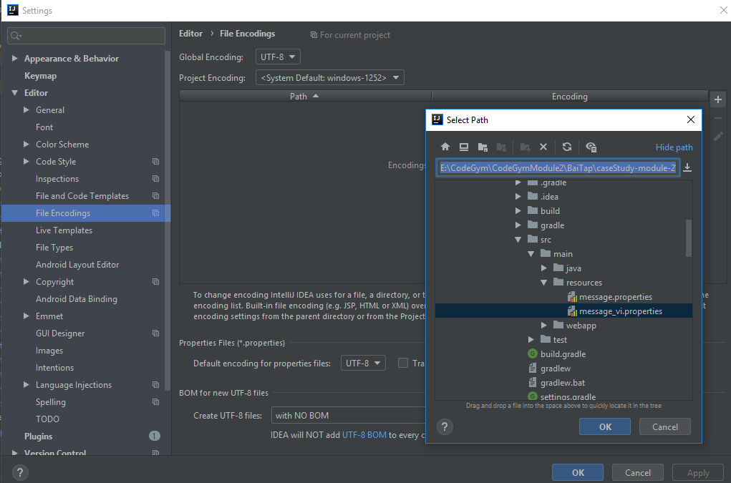

* Ở Controller

@GetMapping(value = "/home", produces = "application/json;charset=UTF-8")